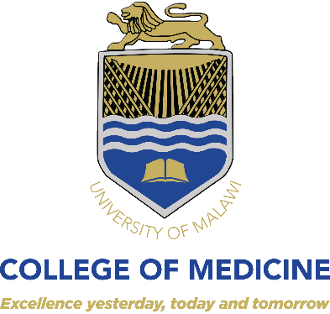
VACANCY ANNOUNCEMENT
Call for applications for Pre-PhD training fellowship
in clinical research for infectious diseases

The College of Medicine (CoM) in collaboration with its research partner (the Helse Nord RHF, Norway) is supporting research capacity strengthening through a fellowship programme in clinical epidemiology/public health. The programme also includes strengthening of capacity of microbiology laboratories within CoM to enhance antimicrobial stewardship. The CoM/Helse Nord collaboration is hereby inviting applications from suitably qualified candidates for an 18 months full-time Pre-PhD fellowship to allow the candidate to develop concepts for PhD research and attend relevant preparatory courses.

Candidates must be interested in infectious diseases clinical research. Specific areas should be on the use of novel diagnostics for tuberculosis or COVID-19. The candidate will be involved in on-going research in the group related to tuberculosis and COVID-19 diagnosis.

Eligibility criteria are as follows:
- Potential candidates must be Malawian nationals
- Candidate must have a Medical degree and completed clinical internship
- Those with a health related Master’s Degree or registered for a Master’s degree or with publications will have added advantage
- At time of application students must submit a 1,500 word (excluding references) research concept or scientific opinion piece on the role of new diagnostic tests in reducing the burden of tuberculosis and COVID-19.

Suitably qualified candidates should forward their applications together with copies of relevant certificates, detailed CVs and names of three traceable referees to:

HOW TO APPLY

The Registrar,
College of Medicine,
P/Bag 360,
Chichiri
Blantyre 3

Indicate the name of the research project as HNTI on the envelope for hard copy applications and indicate the same in the subject line of your email for electronic submissions.
Electronic submissions should be sent to the following e-mail address by 17:00hrs
hr@medcol.mw copy hnti@medcol.mw

Applications should reach the Registrar not later than 21st May, 2021. Only short-listed candidates will be acknowledged.

