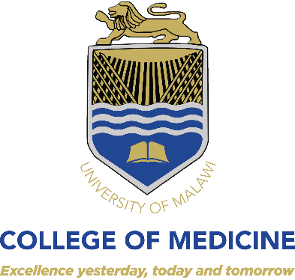
VACANCY ANNOUNCEMENT

TECHNICAL MONITORING AND EVALUATION OFFICER

PROJECT SUMMARY
The Newborn Essential Solutions and Technologies (NEST) 360º program at College of Medicine aims to implement comprehensive newborn care through innovative lifesaving technologies, the provision of both technical and clinical capacity-building, implementation of clinical and technical educational programs and the building of a sustainable distribution network.

DUTIES AND RESPONSIBILITIES:
- Participates in the design, planning and implementation of research projects and data analysis - Identifies, locates and obtains data / information
- Utilizes statistical software to quantify data
- Builds automated reporting solutions
- Manipulates and cleans-up data
- Completes data entry and analysis
- Reports research findings
- Ensures information presented is valid and accurate
- Develops presentations and reports
- Performs all other duties as assigned

Other Functions:

- Designs and develops affordable, high performance clinical technologies for sustainable use in low-resource settings
- Works with external partners to advance technologies towards commercialization.

EDUCATIONAL REQUIREMENTS, SKILLS AND COMPETENCIES

- Bachelor’s degree in Biomedical engineering or other related discipline
- 1-2 years of experience in engineering in clinical research
- Proven skills in engineering, including experience with hospital-related maintenance particularly with regards to neonatal equipment
- Knowledge of qualitative and quantitative data collection, management and analysis using packages such as Tableau, SPSS, STATA, Excel, RedCap, etc.
- Strong data interpretation, report-writing and presentation skills
- Ability to work in a team environment, including ability to coordinate effectively with diverse individuals and stakeholders to achieve results
- Thorough knowledge of Microsoft Office
- Ability to travel extensively in-country and out of country as necessary
- Those with Good Clinical Practice Certificate will have an added advantage

Suitably qualified candidates should forward their applications together with copies of relevant certificates, detailed CVs and names of three traceable referees to:

HOW TO APPLY

The Registrar,
College of Medicine,
P/Bag 360,
Chichiri
Blantyre 3

Indicate the name of the research project as NEST Study on the envelope for hard copy applications and indicate the same in the subject line of your email for electronic submissions. Electronic submissions should be sent to the following e-mail address:
hr@medcol.mw

Applications should reach the Registrar not later than 20th April, 2021. Only short-listed candidates will be acknowledged.

