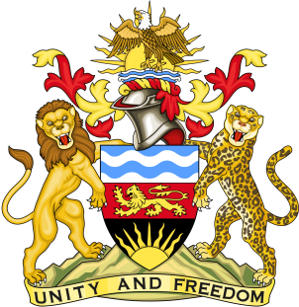

THE MALAWI NATIONAL TUBERCULOSIS CONTROL PROGRAMME

2021 TUBERCULOSIS RESEARCH NETWORKING MEETING

The Malawi National Tuberculosis (TB) Control Programme (NTP) in collaboration with the Kamuzu University of Health Sciences – Helse Nord Tuberculosis Initiative (HNTI) Research Group has organised the “2021 TB Research Networking Meeting".

The objectives of the meeting are as follows:
- Showcase diverse selection of ongoing research in Malawi
- Strengthen the existing Malawi TB Research Network, building on previous initiatives and new opportunities.
- Map key research priorities for next 5 to 10 years in line with the END TB strategy.
- Identify available funding to support TB Research Network in Malawi, and plan for future sustainability.
- Create sustainable platforms for training in tuberculosis research

This two-day blended in-person and virtual conference will comprise key speakers, plenary sessions, abstract driven oral presentations, break-out sessions, talking posters (4 min) /speed talks in the following broad thematic areas:

- Social and behavioural determinants of TB
- Community and facility based interventions for TB prevention and care
- Operational insights from programme activities
- Delivering TB care during the COVID-19 pandemic
- Novel diagnostic (e.g. Molecular assays, CADCXR) and treatment modalities
- Electronic data systems for TB programming and research (e-registers, ePAL etc)
- The role of social and behavioural sciences (incl. Health economics) and civil societies in TB prevention and care
- TB and comorbidities (e.g. HIV, COVID-19, Diabetes, chronic lung disease…)
- Basic TB research in Malawi: Hosts, drugs, and bugs

Venue: Malawi Sun Hotel, Blantyre, Malawi

Dates: 25 and 26 November 2021

All participants are expected to cover their travel and accommodation costs with a limited numbers of travel scholarships available.

Registration: To apply, fill the electronic registration form at https://forms.gle/dVoSzJDwaqw9Np2N7 OR request a registration form from the conference coordinator by email (hnti@medcol.mw).

Abstract submission: Interested presenters are invited to submit their abstracts, which should be in the following format:

- Title (must give a good idea of the disease or problem, type of study and target population): Maximum 120 characteristics.
- List of authors and their affiliations (please underline the presenting author): Maximum 12 Authors.
- Contact details of the presenting author including telephone number and email address
- Introduction
- Methods
- Results
- Conclusions or Interpretation

The abstract should not be more than 300 words in length and should not include any tables or figures. You must clearly indicate if you intend to make an oral or poster presentation. Please note that all abstracts will be peer-reviewed. Abstracts will also be submitted to the conference coordinator by email (hnti@medcol.mw)

Key deadlines: Deadline for registration and abstract submissions is 15 November 2021. Early submissions are encouraged.

Funders: Global Fund, World Bank, Helse Nord RHF (Norway)

